Flatterning json data 2

Dataset 2= emp_details_1:

{

"id":"1",

"name":"srinivas",

"gender":"male",

"language":"english",

"location":"hyderabad"

}

Where data is written on multiple lines not on single line like it was in dataset 1

1. Create souce like created previously for json dataset
2. Now go to source and go to source option->json settings

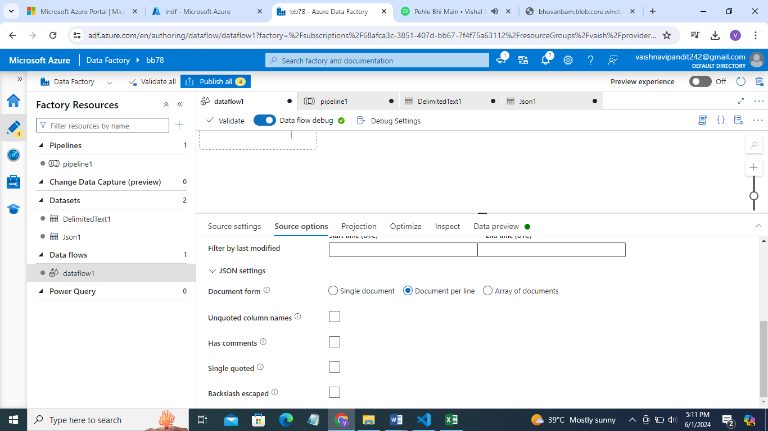

1. Now deselect document per line select array of documents

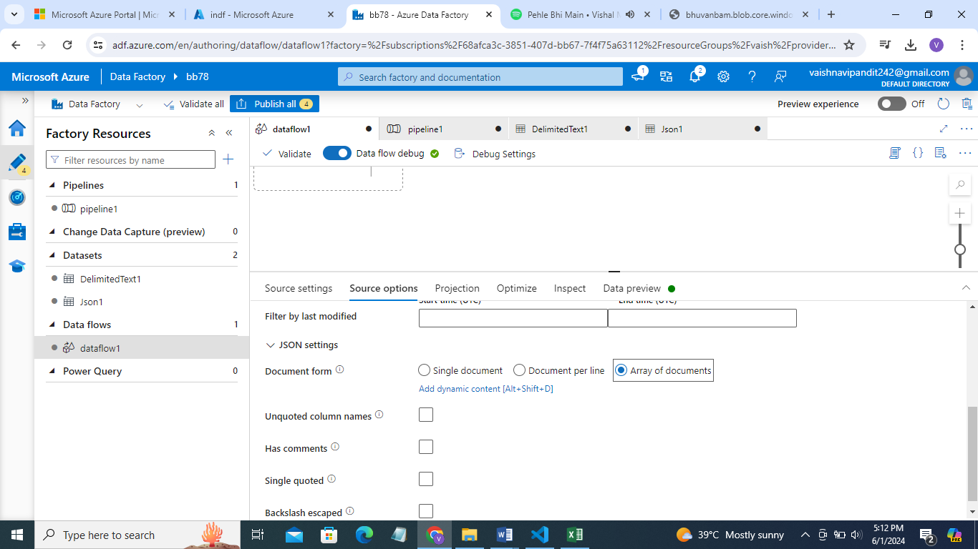

1. Go see preview

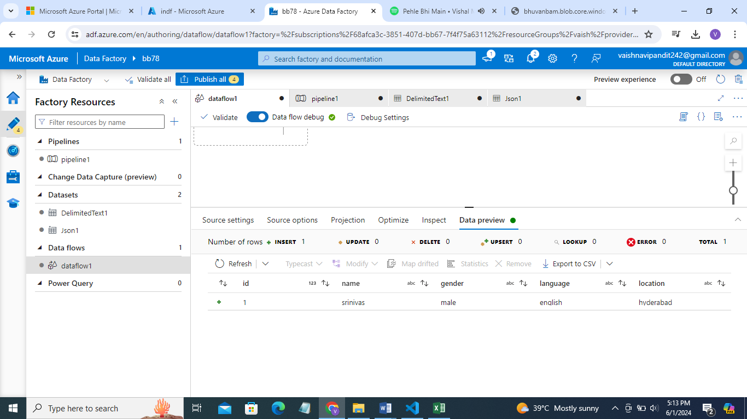

1. Now create sink add sink dataset
2. Add pipeline for dataflow
3. debug